Reviewing Air Pressure.

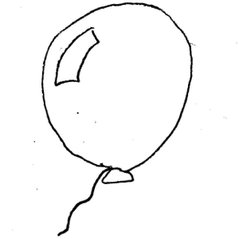
Here’s a balloon. Draw some particles inside the balloon and outside the balloon. How is the spacing of the particles different? Where is the air pressure higher and where is it lower?

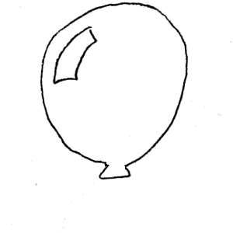

Now I’m going to open the balloon. Draw an arrow to show which way the air inside the balloon flows. Label the inside of the balloon and the outside air with the appropriate phrase: high pressure or low pressure

Why is the air pressure inside the closed balloon different from the pressure outside the balloon? How did the pressure in the balloon get to be different?

Suppose I had two identical balloons. I weighed them when they were empty and they weighed exactly the same. Then I blew one up and measured them again. Do they still weigh the same? Why or why not?

Now write some rules:

Air flows from _________________ pressure to __________________pressure.

Air particles are closer together when air pressure is ______________________.

For the same volume of air, ____________________ pressure air weighs more.

Pushing air together will make the air pressure _______________________.
Applying the Ideas

Now let’s apply those rules in the atmosphere.

Find your map of Wind Speed. This map shows the conditions on December 31, 2009.

The black lines on the map connect points of equal air pressure. If you travel along the line, the pressure is the same. On one side of the line the pressure is higher, and on the other it is lower. The bulls-eyes are areas where the pressure us either highest (H) or lowest (L).

The teeny lines that look like little flags show wind direction. The wind moves FROM the end with the flag TO the pointed end. The wind direction flags are like the arrows you use with a bow and arrow – the flag is like the feathers and the point is like the arrow tip.

- Does your rule about which way air flows work on this map?

- Where on this map would you predict that the densest air would be? The least dense

- Imagine one square inch on the ground. Now imagine the column of air that sits on top of that square inch from the ground all the way up to the edge of the atmosphere. (Remember, we can measure air pressure as pounds per square inch) Find a place on this map where that column of air would weigh more than average, and another place where it would weigh less. Explain your thinking to your group.

(If you are interested in the math, 1 psi = 68.948 millibars, the units on your map).

- Now write a little definition of:

- A high pressure center

- A low pressure center

